Prototype-OM portal_try
25/08/20 17:49
Author: John Doe
File name: Prototype-OM portal_try.vp
Version 1.0

Site Map

01. Site Map / Prototype-OM portal_try

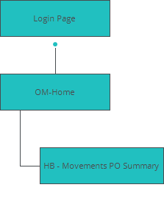

Screens

02. Screens / Prototype-OM portal_try
Login Page
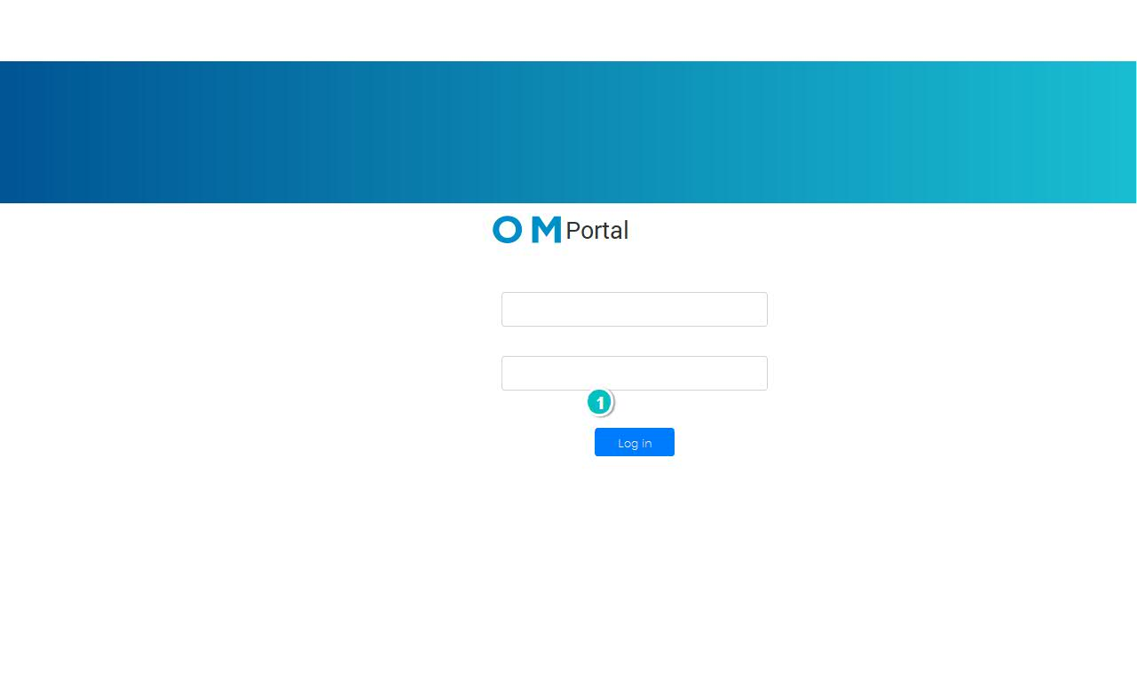

Interactions

1 | on Click: When (not(Text_6.isvisible) and not(Text_7.isvisible)) goes to 'OM-Home' with effect: fade

02. Screens / Prototype-OM portal_try
OM-Home
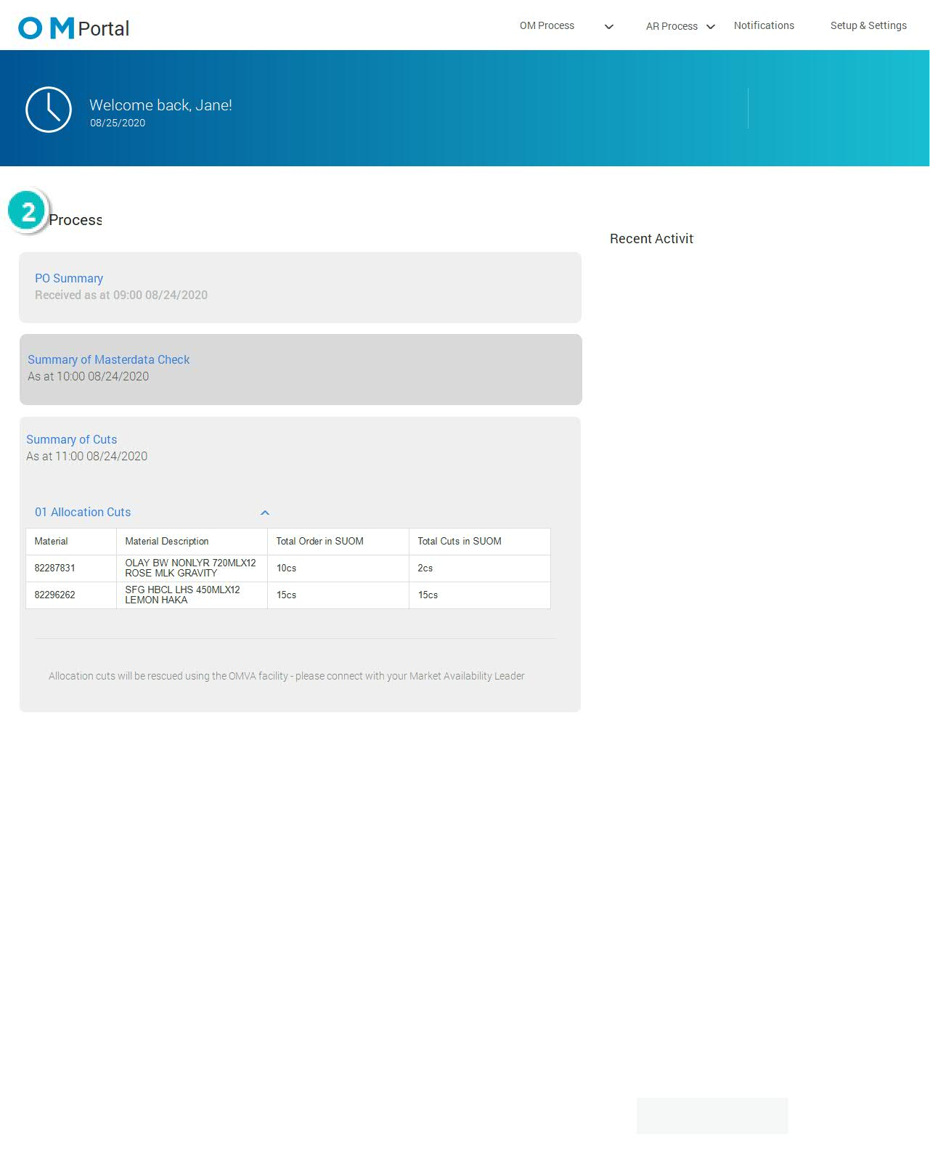

Interactions

2 | on Click: goes to 'HB - Movements PO Summary'

02. Screens / Prototype-OM portal_try
HB - Transfer Summary
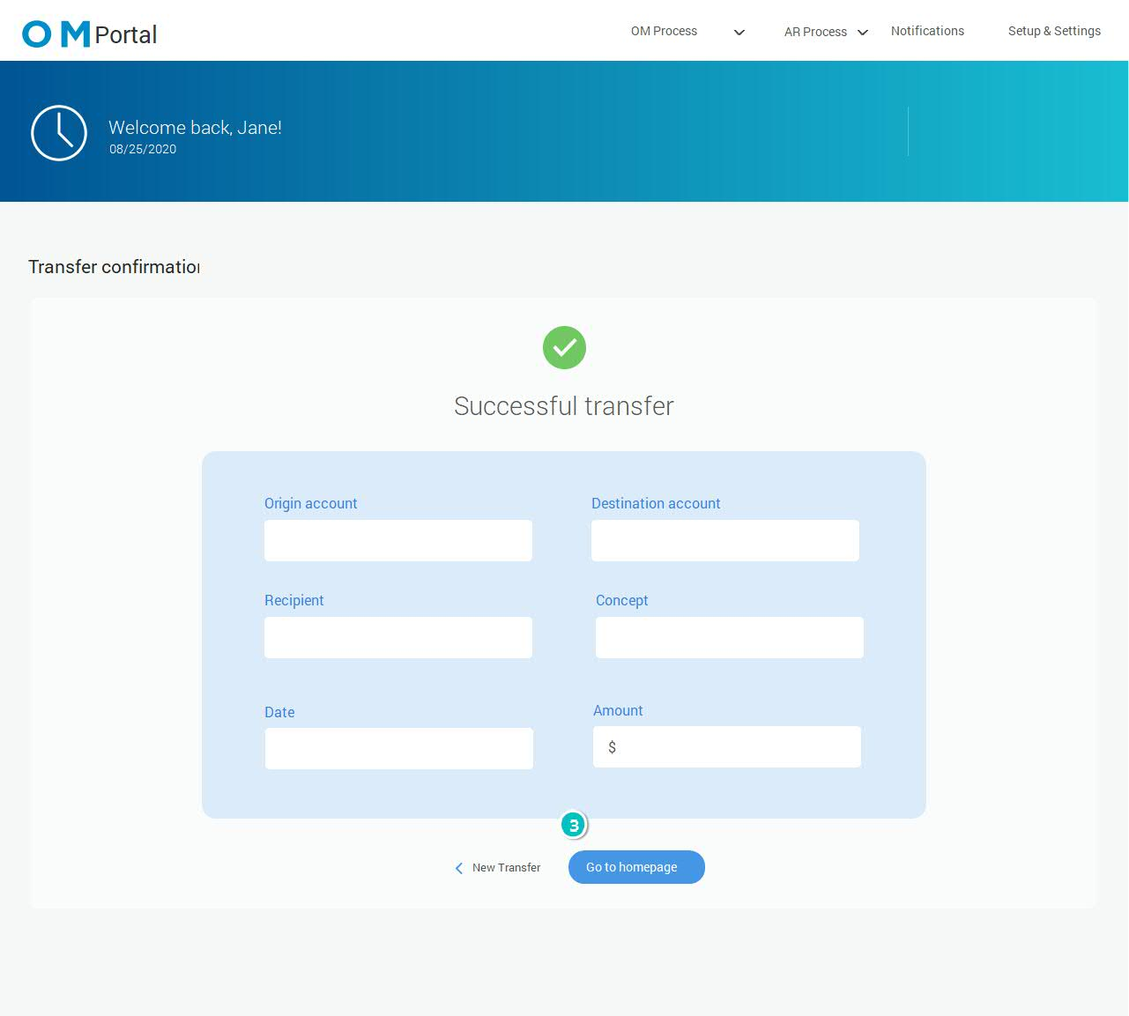

Interactions

3 | on Click: goes to 'OM-Home'

02. Screens / HB - Transfer Summary
Other states
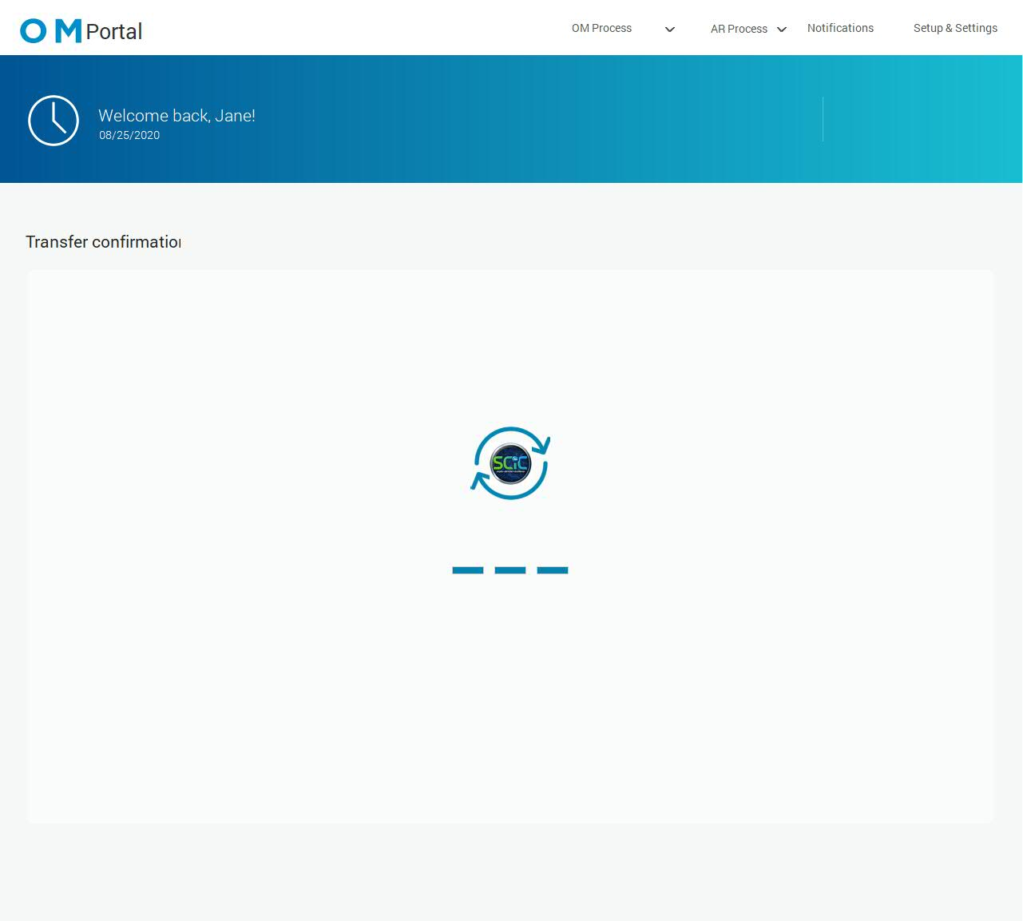

02. Screens / Prototype-OM portal_try
HB - Movements PO Summary
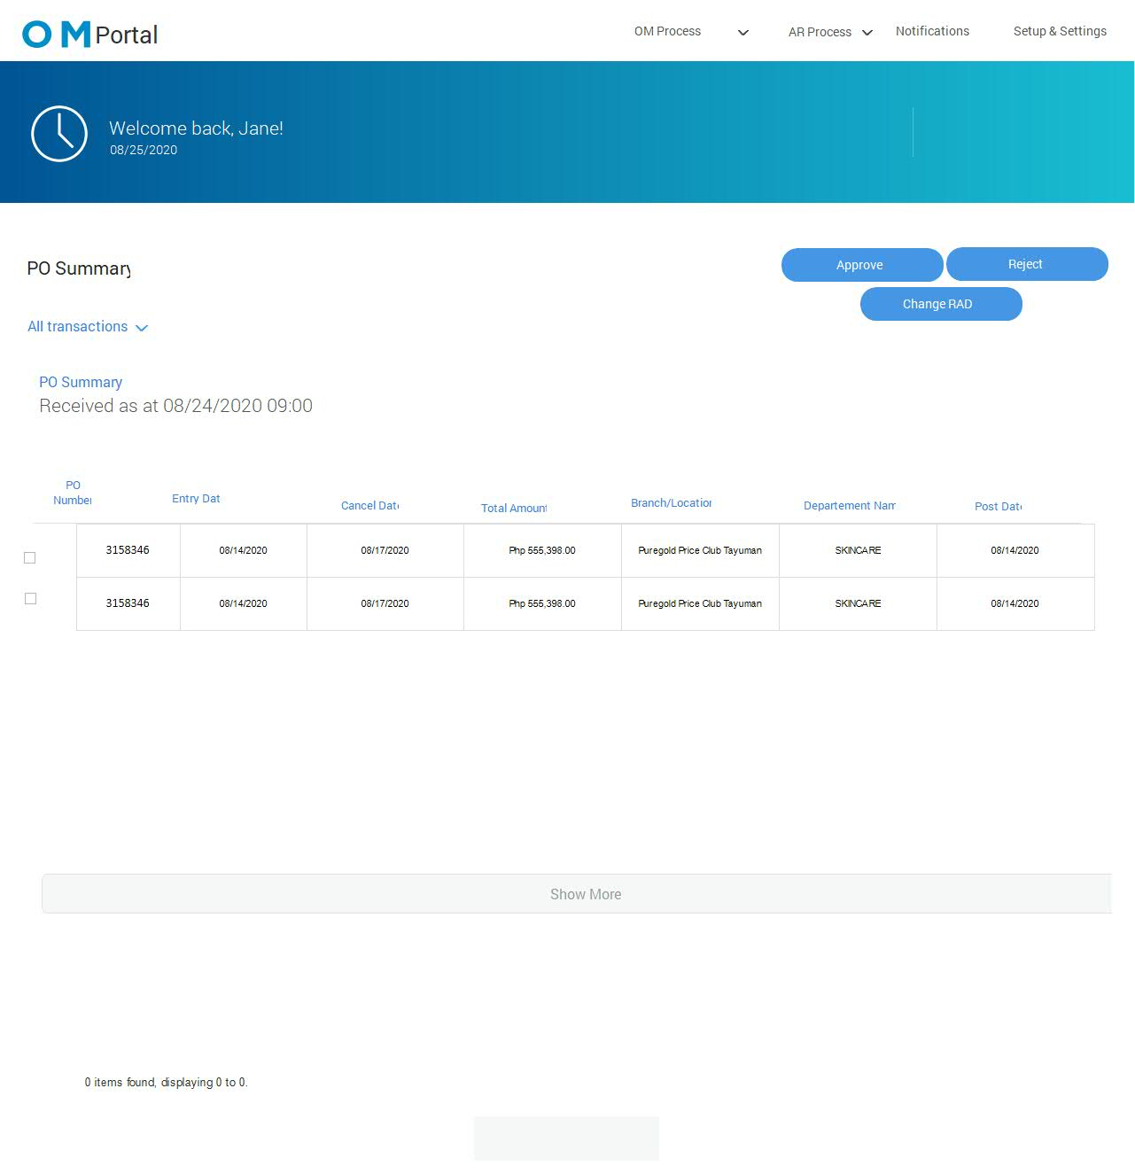

Templates

03. Templates / Prototype-OM portal_try
960 grid - 12 columns

03. Templates / Prototype-OM portal_try
960 grid - 16 columns

03. Templates / Prototype-OM portal_try
Template 1
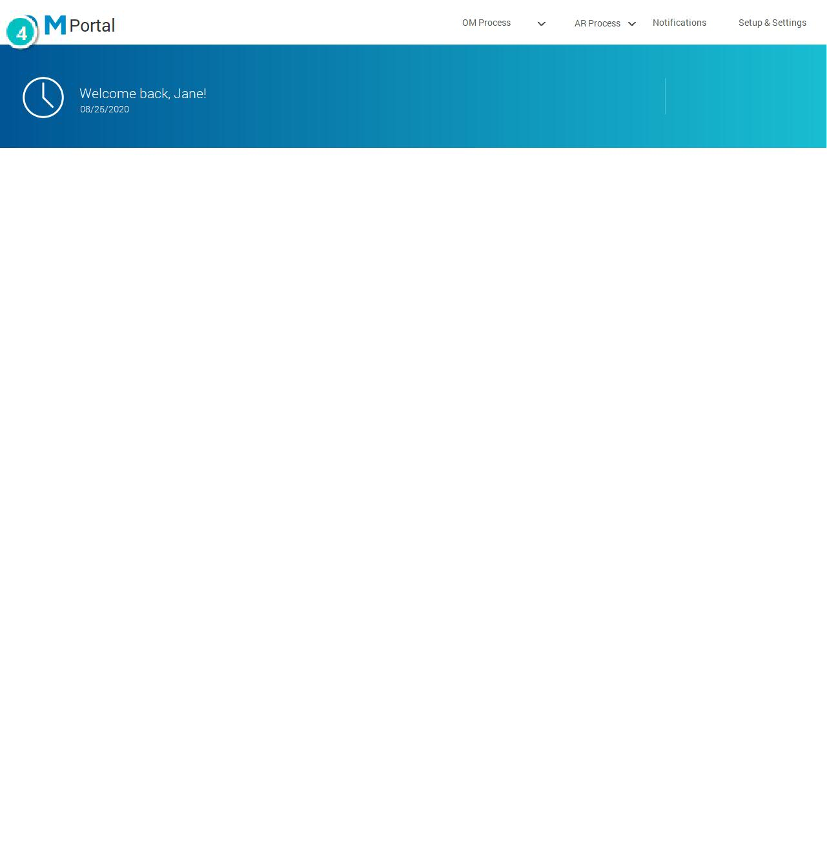

Interactions

4 | on Click: goes to 'OM-Home' with effect: fade

03. Templates / Prototype-OM portal_try
Template 2
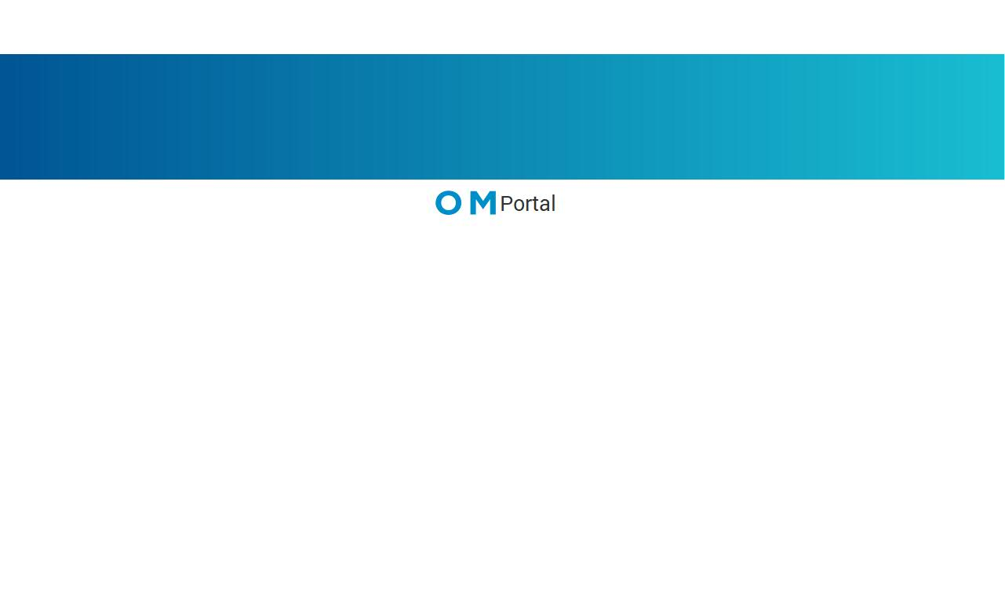

Scenarios

04. Scenarios / Prototype-OM portal_try
default

