Problem: I’m currently having problems defining what goes into the category. As you can see I defined this specific field as a category in data master.

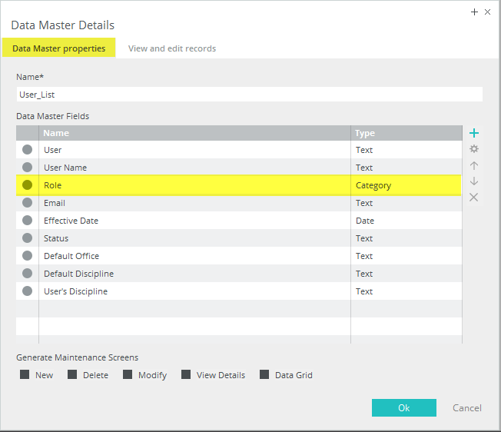

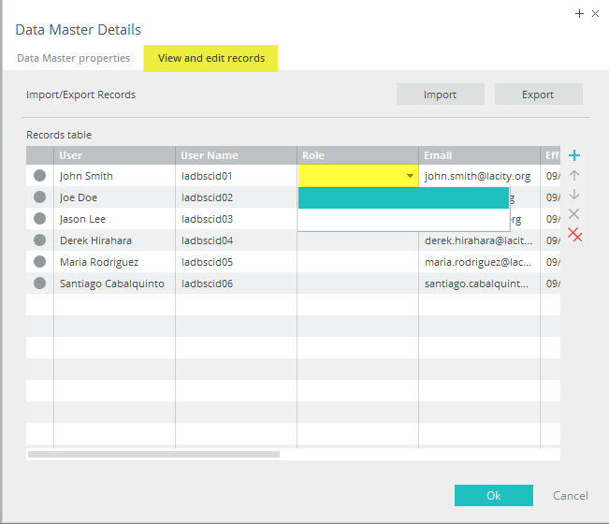

After clicking on the drop down selection under roles, I am unable to define the actual roles themselves and the only thing that appears are two blank boxes. Is there a way I can manually input the role types that I want to add or is there another step that I am missing? Thank you!

